# “BUILD YOUR PC ”

### A Project report submitted

**In the partial fulfillment the award of degree of**

**BACHELOR OF TECHNOLOGY**

**IN**

**COMPUTER SCIENCE AND ENGINEERING (2022-2023)**

**BY**

**B.Hemanth – 211801390004**

**M.Satya Dinesh - 211801360005**

**S. Murali Krishna – 211801390012**

**P.Sai Vikas – 211801340011**

**Under the esteemed Guidance of**

**Mrs. G. Rama Devi, M.Tech,(Ph.d),Asst. Professor**

**CENTURION UNIVERSITY SCHOOL OF ENGINEERING AND TECHNOLOGY**

**Rollavaka village, Tekkali mandal 535003**

**(2022-2023)**

**CENTURION UNIVERSITY OF TECHNOLOGY AND MANAGEMENT**

**ANDHRA PRADESH**

**(2019-2023)**

**COMPUTER SCIENCE AND ENGINEERING**

BONAFIDE CERTIFICATE

##### This is to certify that the project work entitled “BUILD YOUR PC” is a fulfillment of project work done by group members for the award the degree of BACHELOR OF TECHNOLOGY in COMPUTER SCIENCE AND ENGINEERING, CENTURION UNIVERSITY OF TECHNOLOGY AND MANAGEMENT, during the academic year 2022-2023.

##### INTERNALGUIDE HEAD OF THE DEPARTMENT

##### Mrs .G. Rama Devi Mr.R.Lakshman Rao

**Asst. Professor**

**Dept. of CSE Dept. of CSE**

**EXTERNAL EXAMINER**

**ACKNOWLEDGEMENT**

It is with at most pleasure and excitement we submit our project partial fulfillment of the requirement for the award of Bachelor of Technology.

The project is a result to the cumulate efforts, support, guidance, encouragement and inspiration from many of those for whom we have to give our truthful honor and express gratitude through bringing out this project at the outset as per our knowledge.

I convey my special thanks to our project **Guide Mrs. G. Rama Devi(Asst. Professor)** who has guided, encouraged and tremendously supported me to enhance my knowledge with present working of this project to bring out enriching the quality of project.

I express my appreciativeness to **Mr. R.LAKSHMAN RAO(Asst. Professor) and Head of the Department,** who facilitated us to providing the friendly environment which helped to enhance my skills in present project.

I would also like to extend my gratitude to **Dr. K. V. G. KRISHNA MURTHY, Dean-School of Engineering And Technology, Centurion University of Technology and Management** who has helped us to attain all the requirements of the project.

I convey my sincere thanks to **Dr. RAMANA RAO, Ph. D Registrar of Centurion University of Technology and Management** who provided us with an opportunity to take on project work in well-equipped laboratories of Computer Science Department in our college.

At the outset, we thank to **Sri. G.S.N.RAJU**, beloved **Vice Chancellor of Centurion University of Technology and Management** who is the back bone by providing for completion of this project, Thank you sir.

**DECLA****RATION**

I hereby declare that the project entitled **“BUILD YOUR PC”** submitted to the fulfillment of award the degree of **B.TECH (CSE)** in **CENTURION UNIVERSITY OF TECHNOLOGY AND MANAGEMENT**, **ANDHRA PRADESH.**

**B.Hemanth – 211801390004**

**M.Satya Dinesh - 211801360005**

**S. Murali Krishna – 211801390012**

**P.Sai Vikas – 211801340011**

Table of Contents

1 INTRODUCTION 1

1.1 Purpose 1

1.2 Scope 1

1.3 Problem Definition 2

1.4 Audience 2

1.5 Tools to be Used 2

1.6 References 2

1.7 Overview 2

2. GLOSSARY 4

2.1 Definitions 4

2.2 Acronyms and Abbreviations 4

3. SYSTEM MODEL 6

3.1 State Transition Diagram 6

3.2 Sequence Diagram 7

3.3 Use Case Diagram 8

3.4 Data Flow Diagram 9

4. FUNCTIONAL REQUIREMENT 11

4.1 User Class 1- Non Registered Users 11

4.2 User Class 2- Registered Users 12

5. NON FUNCTIONAL REQUIREMENTS 14

5.1 Security Requirements 14

5.2 Performance Requirements 14

5.3 Safety Requirements 14

6. SYSTEM EVOLUTION 15

7. REQUIREMENT SPECIFICATION 16

7.1 Product Perspective 16

7.1.1 Hardware Interface 16

7.1.2 Memory Constraint 16

7.2 Product Function 16

7.3 Database Requirement 16

7.4 User Characteristics 20

7.5 Assumptions and Dependencies 20

# 1.INTRODUCTION

This document includes software requirements specifications for an Build your PC website. This Website is developed to connect buyers and sellers across the country seeking to buy and sell products online conveniently for free without any third parties in between. Internet is a great promotional vehicle and communication channel for connecting buyers and sellers. Consumers can find a product of interest in visiting the website of the retailers (sellers) directly or by searching among the alternatives using a shopping search engine. For the consumers searching for cheap products to buy online and sellers desiring to get some profit out of some unused stuffs, Amazon.com is the best website.

## Purpose

It will explain system constraints, interface and give a complete declaration for the development of the system. The website can be used by users to browse, search and add products to sell to the buyers.

## Scope

This Build your PC website designed to facilitate buying and selling of products between consumers without the involvement of businesses and hidden costs. The functions that a user will be able to perform in this platform are:

1. Register to the platform
2. Log in to the platform
3. Browse through the database of available product
4. View user profile
5. Get contact information of the seller
6. View product dashboard

## Problem Definition

The online market is flooded with the availability of online stores including a third party involved either in the case of storage or in the case of delivery/distribution, which normally includes a huge amount of money being expensed in the both shipping and extra charges. So to overcome such concepts we have decided to make a customer to customer transaction based online system where the buyers and sellers make a reasonable discussion of the product project, a need for the study of database and some designing was a must, and what better a way to study all those than to design a functional website. Current online websites involves a third party with the charges of  shipping involving many extra charges which is completely reduced in our website, also reducing the over prince hike in the normal products.

## Audience

People interested in buying and selling their products without the involvement of any middleman and free of charges are the targeted audience of this platform.

## Tools to be Used

Programming Language: HTML, CSS, JavaScript and Bootstrap for front-end.

PHP for back-end.

Database: MySQL

Platform: XAMPP

## References

Somerville, Software Engineering, 10th ed. England: Addison-Wesley, 2017

## Overview

This web platform to buy and sell products without any charges, similar to a forum of discussion but for posting and buying online products. Since, it will be designed as a web platform; it can be easily accessed by anyone with Internet access and web browser in their device. The advantages of our platform are:

1. Browse and search products easily.
2. Add products without any charges.
3. View product and its details.
4. Contact sellers directly.

**2.GLOSSARY:-**

**2.1 Definitions:**

Email Authentication

Email authentication is a technical solution to proving that an email is not forged. It provides a way to verify that an email comes from whom it claims to be from. Email authentication is most often used to block harmful or fraudulent uses of email such as phishing and spam which has been implemented in this platform.

Interface

The interaction between a user and system running on a Web server. The user interface is the Web browser and the Web page it downloaded and rendered.

Class

Class is a blueprint or prototype that defines the variables and the methods common to all objects of a certain kind.

Attribute

A database attribute is a column name and the content of the fields under it in a table in a database.

## 2.2Acronyms and Abbreviations

HTML: Hypertext Markup Language

CSS: Cascading Style Sheet

DB: Database

DESC: Description

ER: Entity Relationship

DFD: Data Flow Diagram

**3. SYSTEM MODEL**

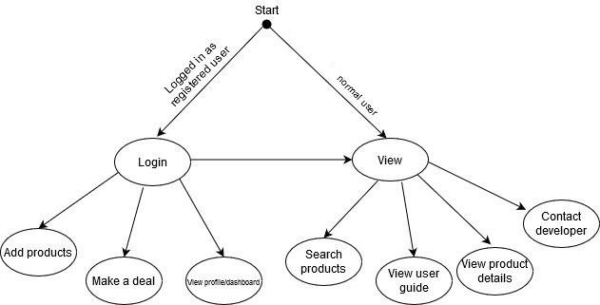**3.1 State Transition Diagram**

Figure 1: State Transition Diagram

State transition diagrams are used to give an abstract description of the behavior of a system. This behavior is analyzed and represented by a series of events that can occur in one or more possible states. Here the system is started with an initial state which is black dot as shown in the above figure. Logged in registered users have privilege to more states than normal users.

3.2 **Sequence Diagram**

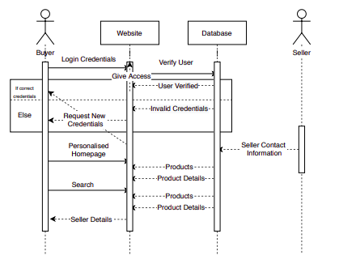

Figure 2: Sequence Diagram

A sequence diagram simply depicts interaction between objects in a sequential order i.e. the order in which these interactions take place. The above figure shows the interaction of the user with various objects of the system acted in sequence to carry out several tasks by user.

* 1. **Use Case Diagram**

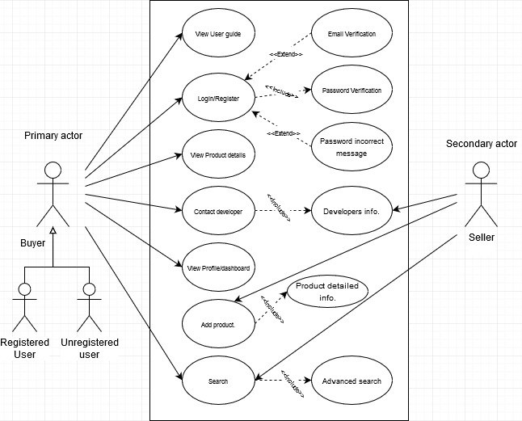

Figure 3: Use Case Diagram

A use case is a representation of a user’s interaction with the system that shows the relationship between the user and the different use cases in which the user is involved. The above figure shows the use cases of the user in the system. The user must be logged in to perform use cases like add products, view profile, view products dashboard.

## Data Flow Diagram

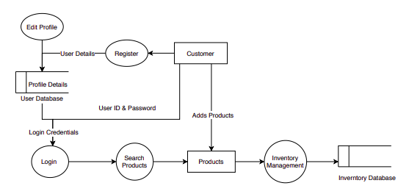

Figure 4: Level 0 DFD (Context Flow Diagram)

A data flow diagram (DFD) is a way of representing a flow of data of a process or a system. DFD describes the processes that are involved in a system to transfer data from the input to the file storage and reports generation.

# 4 .FUNCTIONAL REQUIREMENT

## 4 .1 User Class 1- Non Registered Users

Functional Requirement 1

TITLE: Register to the website

DESC: The non-registered users can register into the website by entering first name, middle name, last name,username, email, password and then verify email. If verification is successful then the page is redirected to the login page.

Functional Requirement 2

TITLE: Search for products

DESC: A search bar available in the platform can be used to search for the required product. Users can also search through the category of products. Users can input key words in the search bar and if the relevant match is found, then the title matching the word is displayed otherwise, ‘No products found’ message is displayed.

Functional Requirement 3

TITLE: View product details

DESC: The information like general details, seller details, product description, pricing details, delivery and warranty details can be seen.

Functional Requirement 4

TITLE: Contact the developer

DESC: Users can contact any developer by clicking the different social media links associated with the developer for which the information like name, email and message is required.

Functional Requirement 5

TITLE: View the website user manual

DESC: User can visit help page to view the website user manual. The user manual contains the instructions on how to register to the platform, deal with forgotten password, search for products, contact the seller and so on.

## 4.2 User Class 2- Registered Users:-

Functional Requirement 1

TITLE: Login to the website

DESC: Registered users can log in to the system using their credentials. If username or email and password match then, users are logged in to the platform otherwise, error message for invalid username and password is displayed.

Functional Requirement 2

TITLE: Search for products

DESC: A search bar available in the platform can be used to search for the required product if available in the database. Both registered and non-registered users can search through the category of products.

Functional Requirement 3

TITLE: View product detail

DESC: The information like general details, seller details, product description, pricing details, delivery and warranty details can be seen like non-registered users.

Functional Requirement 4

TITLE: Add product

DESC: Users can add product and its details with their information. They must specify product name, product category, picture of the product, owner name, and description of product, price details, product condition, warranty and home delivery details.

Functional Requirement 5

TITLE: View profile

DESC: Users can view their name, gender, username, email, contact number, birthdate, profile picture

Functional Requirement 6

TITLE: View product dashboard

DESC: Users can view the number of products they have added to sell, requested to buy and been offered for the product they put on sale

Functional Requirement 7

TITLE: Contact the developer

DESC: Users can contact any developer by clicking the different social media links associated with the developer for which the information like name, email and message is required.

Functional Requirement 8

TITLE: View the website user manual

DESC: User can visit help page to view the website user manual. The user manual contains the instructions on how to register to the platform, deal with forgotten password, search for products, contact the seller.

**5 . NON FUNCTIONAL REQUIREMENTS:**

The system should meet the following non-functional requirements:

## 5.1 Security Requirements

1. Users need to create password containing minimum of 8 alphanumeric characters with both uppercase and lowercase letters including a number.
2. Users need to verify their email after registering to enter the platform as registered user.
3. Only the registered users can add products.

## 5.2 Performance Requirements

1. The web design is responsive, attractive and, easy-to-navigate.
2. The page loads fast without delay of more than one second.
3. There is a focussed shopping approach with searching and filtering functionality.

## 5.3 Safety Requirements

1. The platform is hosted by a secure hosting infrastructure.
2. It gives a pop-up message whenever an error or accidental decision is made.

**6.SYSTEM EVOLUTION :-**

The system evolved by proposing the website with little functionality. We started off by building the basic register and login system with general authentication requirements. We worked on the initial requirements and analyzed it in parallel, and several new requirements came into existence. Later on, we changed the general authentication to robust authentication system with email verification. Then, we added features like customer dashboard and customer profile.

**Initial Stage of Website**:

Features:

General Authentication

Basic Search

Add products

**Final stage of website**:

Features:

Advanced Search

Customer Dashboard

Customer Profile

Website User Manual

**7.REQUIREMENT SPECIFICATION :-**

## Product Perspective

## 7.1.1 Hardware Interface:-

The system can be interfaced through the use of mouse, keyboard and output screen. This system is also accessible and compatible on mobile screen devices provided that the accessing system has internet access.

7.1.2 Memory Constraint:-

No specific constraints on memory.

## 7.2 Product Function

There are mainly two types of users:

**7.2.1 Normal users:** Users without signing in to the system.

* Users can search the products.
* Users can view the company profile.
* Users can view product profile.
* Users can access the user manual.

**7.2.2 Authorized users:** Users with verified username and password.

* They will have all the privilege of the normal users.
* They can add products.
* They have their own profile.
* They have their own dashboard containing products detail.

## 7.3 Database Requirement

**Users**

The user table is used to store the new users. This table includes id as primary key which is auto generated and incremented. The user can login to the system by entering valid username and password. This table also stores information for contacting while buying and selling the products.

|  |  |  |
| --- | --- | --- |
| **Attribute** | **Type** | **Required** |
| id | int | Auto Generated  primary key(True) |
| USERNAME | varchar | True |
| age | int | true |
| email | varchar | True |
| password | varchar | True |

**Products**

Every registered user can view the products, buy the product as well as sell their product by adding their product in their profile which is then posted publicly. This table contains the basic properties of the products like product name, price, email of the user, and the category under which it is categorized normally.

|  |  |  |
| --- | --- | --- |
| **Attribute** | **Type** | **Required** |
| id | int | Auto Generated  primary key(True) |
| name | varchar | True |
| price | int | True |
| email | varchar | True |
| category | varchar | True |

**contact**

This table stores the information of the requests made by the registered user and the requests made to the user by the probable buyer who are also the registered user on the site and the requests are stored on the profile page of the user.

|  |  |  |
| --- | --- | --- |
| **Attribute** | **Type** | **Required** |
| id | int | Auto Generated  primary key(True) |
| Contact to | varchar | True |
| Contact by | varchar | True |

**Product details**

This table contains the detailed information of the products that includes product name,company, price, condition of the product, for how long it has been used till the date which is uploaded in the

**7.4** **User Characteristics**

The Kinmail platform is used by anyone that has access to the Internet and a web browser. It is assumed that the user is familiar enough with a computer to operate the browser, keyboard and mouse.

There are two types of users: Normal User (Non-Registered) and Registered User.

The normal users can use the platform to create an account, browse and search different products. They can view different products, product details, and contact website user manual.

The registered users have all privilege of normal users. They can add products, view profiles, and view product dashboard.

## 7.5 Assumptions and Dependencies :

**Users**:

We have assumed that all the users using this platform are capable of connecting their devices to the Internet and navigate the browser on their devices to the address of Kinmail website.

**Provider**:

The success of the system depends on:

* The performance of the platform is good.
* The information stored are secured and verified.
* The system is built with the perspective of HCI.